Name: ______________________________ Period: _______________

Pre-lab for Balancing Act

The following picture represents a board that can pivot at its center

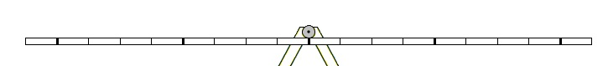

1. Draw what would happen to the board if you stood on one end.

2. You have two identical 10 kg bricks. Carefully draw where you would place each brick on the board so that the board stays balanced. (More than one possible correct answer)

3. Now draw the forces from each brick in your picture above.

4. You have a 10 kg brick and a 20 kg brick. Carefully draw where you would place each brick on the board so that the board stays balanced. . (More than one possible correct answer)

5. Now draw the forces from each brick in your picture above, and explain why the board stays balanced.

