Name______________________________
Isotopes and Atomic Mass

1. To begin, select the Make Isotopes tab and expand the Symbol and Abundance in Nature menus.

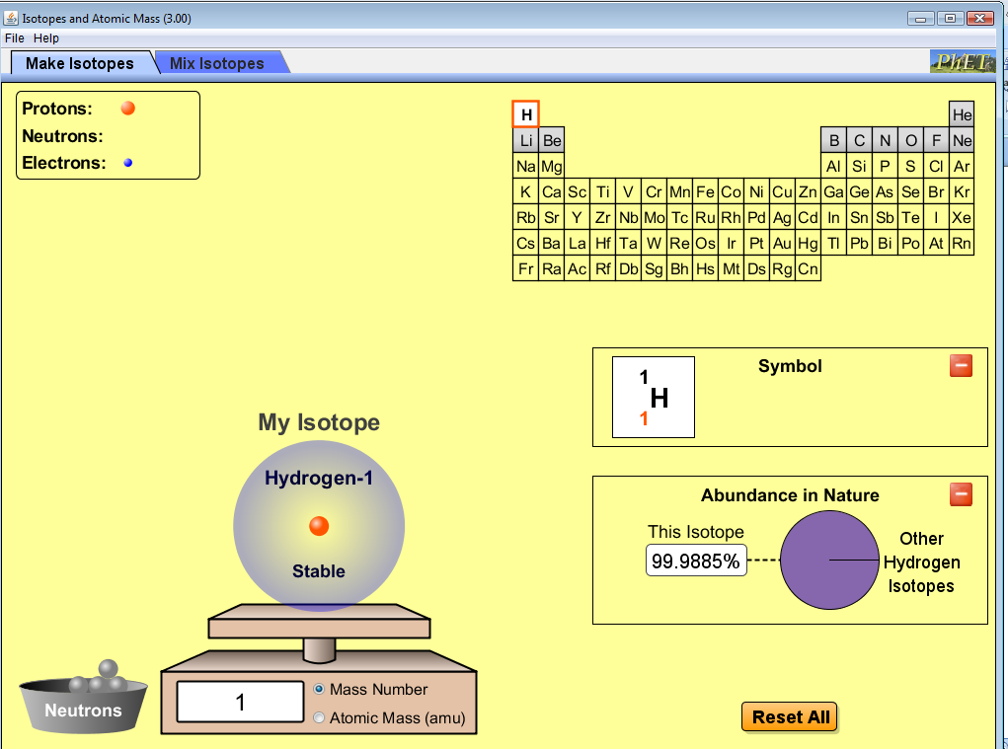
2. Add neutrons to the hydrogen isotope. How does adding neutrons affect the isotope symbol?

3. As neutrons are added, comment on the stability of the isotope.

4. How does the stability of an isotope relate to its abundance in nature? Why might this be the case?

5. Play around with the sim until you are comfortable with the relationship between neutrons, mass number, symbol, and abundance in nature. You can select a new element by using the periodic table at the top right. Write at least three conclusions from your exploration.

6. Complete the following table. This information will be important later.
Isotope | Symbol | Abundance in Nature | Mass Number | Atomic Mass (amu)
Hydrogen -1
Protium
Hydrogen -2
Deuterium
Hydrogen -3
Tritium

7. Next, select the Mix Isotopes tab and make sure your screen looks like this before proceeding.
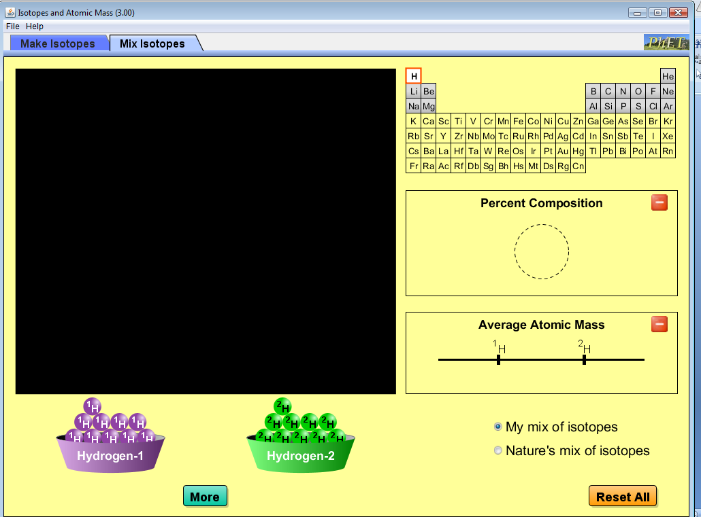
8. Drag hydrogen isotopes (purple and green atoms) into the black box. Notice how the percent composition and average atomic mass data changes. As you add more atoms to the box, record at least three different observations. You may add as many of each isotope (color) as you like.

9. After completing Step 8, Reset All. In order to discover the relationship between percent composition and average atomic mass, it is helpful to be more systematic when choosing the number of atoms in the simulation. Complete the following table by adding purple and green atoms to the black box. In order to add larger amounts, Click “More” and use the slider bar or numerically enter data.
# of atoms  Hydrogen-1  Purple | # of atoms  Hydrogen-2  Green | % Hydrogen-1  Purple | % Hydrogen-2  Green | Average Atomic Mass  (amu)
1 | 1
5 | 5
5 | 10
10 | 5
1 | 10
10 | 1
20 | 1
50 | 1

10. The average atomic mass for hydrogen is listed as 1.007 amu on the periodic table. Predict the combination of purple and green atoms required to achieve this mass.

11. Check your prediction by clicking on “Nature’s mix of isotopes”.

12. Look at the table you completed in Step 6 as well as the information on this page. What conclusions can you draw between abundance in nature, percent composition, and average atomic mass?

13. Carbon has an average atomic mass of 12.011 amu (as given on the periodic table). Which isotope of carbon do you think is most abundant: carbon-12 or carbon-13? Explain your answer. Check your response by using the sim to select carbon and clicking on “Nature’s mix of isotopes”.

14. Boron has an average atomic mass of 10.81 amu (as given on the periodic table). Which isotope of boron do you think is most abundant: boron-10 or boron-11? Explain your answer. Check your response by using the sim to select boron and clicking on “Nature’s mix of isotopes”.

15. Bromine’s two major isotopes are bromine-79 and bromine-81. Based on the average atomic mass given for bromine on the periodic table (79.904 amu), what can you conclude about the percent abundance/composition of the two isotopes in nature?

16. Define the term average atomic mass using your own words.

