Phet- Circular Motion
- Open the Phet simulation titled “Ladybug Revolution”
- If the ladybug is at the red point on the turntable, draw your prediction of the velocity and acceleration vectors of the ladybug if the table is turning counterclockwise. (notice you are observing an overhead view of the turntable)
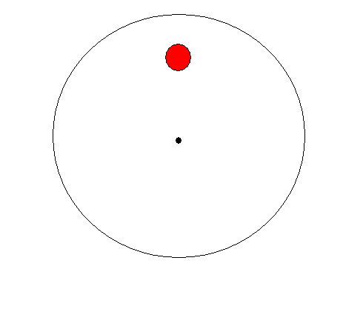
- First use the intro tab and make sure that both the “show velocity vector” and the “show acceleration vector” are checked.
- If you click on the ladybug you can move it to different positions on the turntable.
- Set the ladybug in a similar position to the ladybug above and enter an angular velocity of 150 degrees/second. Draw your results below.
- Did your results agree with your predictions?

- Now click on the rotation tab. Bring up the ruler and make sure the bug is at 2mm from the center and remove the ruler. (Note, the ruler is labeled in mm, but calculations are in meters, treat the ruler readings as if were labeled in meters).
- Fill out the following table using different angular velocities for the given radius. Run each simulation for 5 seconds and observe the graphs.
  - Underneath “Show graphs” you will need to click $θ$,ω,a to get your acceleration.
  - Underneath “Show graphs” you will need to click $θ$,ω,v to get your velocity.
Angular velocity | Radius | Velocity | Velocity^2 | Acceleration
 | 2 m
 | 2m
 | 2m
 | 2m

- Repeat step 8 using a radius of 3 m.
Angular velocity | Radius | Velocity | Velocity^2 | Acceleration
 | 3m
 | 3m
 | 3m
 | 3m

- Do you notice any relation between the velocity^2, radius, and acceleration?

- From the graphs do you notice the magnitude of the velocity or the magnitude of acceleration changing as angular velocity stays the same, if so how?

- In linear motion, when you have a constant acceleration, how does this affect the velocity? Is this different from circular motion? Explain.

