Learning Goals:
Students will be able to:
- Relate the real-world example of making sandwiches to chemical reactions
- Describe what “limiting reactant” means using examples of sandwiches and chemicals.
- Identify the limiting reactant in a chemical reaction

Directions:
- Use Reactants, Products, and Leftovers simulation to create your own sandwiches and then see how many sandwiches you can make with different amounts of ingredients.

Test your learning:

- a. Predict (without using the sim) how many cheese sandwiches, as defined by the picture to the right, you can make if you have 6 pieces of bread and 4 slices of cheese.
b. Talk with your partner about your thinking to get the answer.
c. Then, use the sim to check your answer and make any corrections.

- a. Predict what would change about your number of sandwiches and thinking if you had the same 6 pieces of bread and 4 slices of cheese, but the sandwich is made like the picture on the right?
b. Check your prediction using the sim and make any changes.

- Why did the number of sandwiches change even though the amounts of ingredients were the same? Research what “limiting reactant” means and then write a description in your own words using the situations in #2 and #3 as supporting evidence.

- A tricycle factory gets a shipment with 400 seats and 600 wheels. Use your ideas about Limiting Reactants to explain how you would figure out how many tricycles can be made.

Relate the model to Chemistry:
- The balanced chemical reaction for producing water is: 2 H₂ + 1 O₂ → 2 H₂O.
Research the “The Law of Definite Proportions” and explain why the simulation doesn’t have choices for the ratio of hydrogen and oxygen like it does for cheese, bread, and meat.

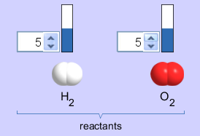
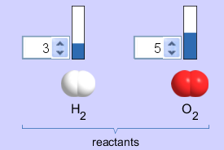
- Predict which reactant amounts would get the most water with the least amount of leftovers. Explain how your understanding of Limiting Reactant helped you figure this out.
5
5
5
5
3
3
